**PROJECT TITLE:**

### Plasma Donor App With AWS Serverless Computing

### **INTRODUCTION:**

### **Overview:**

Plasma is the clear, straw-colored liquid portion of blood that remains after red blood cells, white blood cells, platelets and other cellular components are removed. In Convalescent Plasma Therapy (CPT), plasma collected from recovered patients is infused into patients who currently have the disease.

CPT is, by far, the oldest treatment being tested to battle COVID-19, being successful in cases during the previous coronavirus outbreaks such as the Sars epidemic in 2003 and the Ebola virus outbreak in 2013. Physicians used CPT effectively before the specific treatment was developed for H1N1 influenza (Spanish virus), SARS-1 and MERS virus.

**Purpose:**

The main goal of the project is to make it easier for the COVID-19 patients to get a plasma donor easily and as soon as possible as it is too difficult to find a plasma donor. In most of the cases, it has seen that COVID-19 patients look for plasma in facebook groups or just by posting randomly which in some cases is not helpful. Here this project will help the patient to find a donor fast when they need it.

**Project Flow:**

Serverless computing is the current trend in software application development. Microservices are a popular new approach for building maintainable, scalable, cloud-based applications. AWS is the perfect platform for hosting microservices. In this project, we will be building a plasma donor app with AWS services like lambda functions, API gateway, and DynamoDB.

* The user interacts with the application.
* Register by giving the details as a donor.
* The database will have all the details and if a user posts a request then the concerned blood group donors will get notified about it.

**RESULTS:**

**Ec2 public DNS LINK:** [**http://ec2-100-25-35-95.compute-1.amazonaws.com:8080/**](http://ec2-100-25-35-95.compute-1.amazonaws.com:8080/)

**Screenshots:**

1. **Login Page**

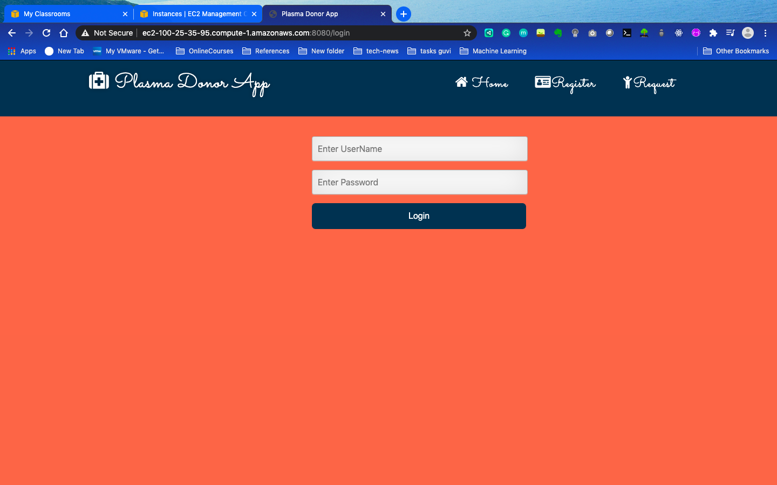

1. **Registration Page**

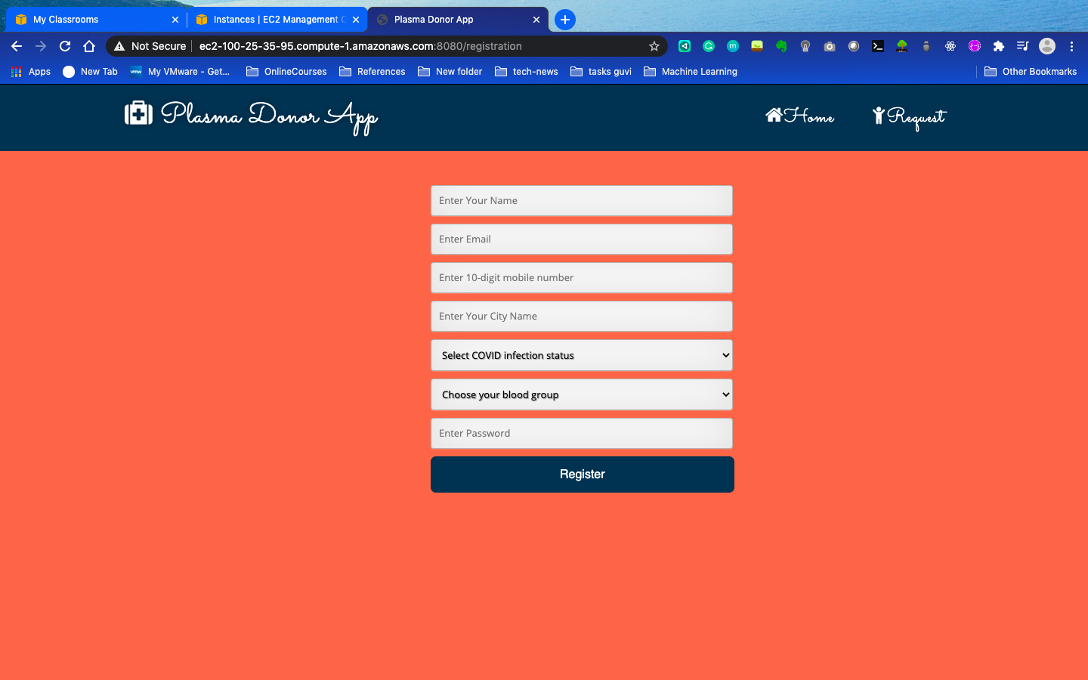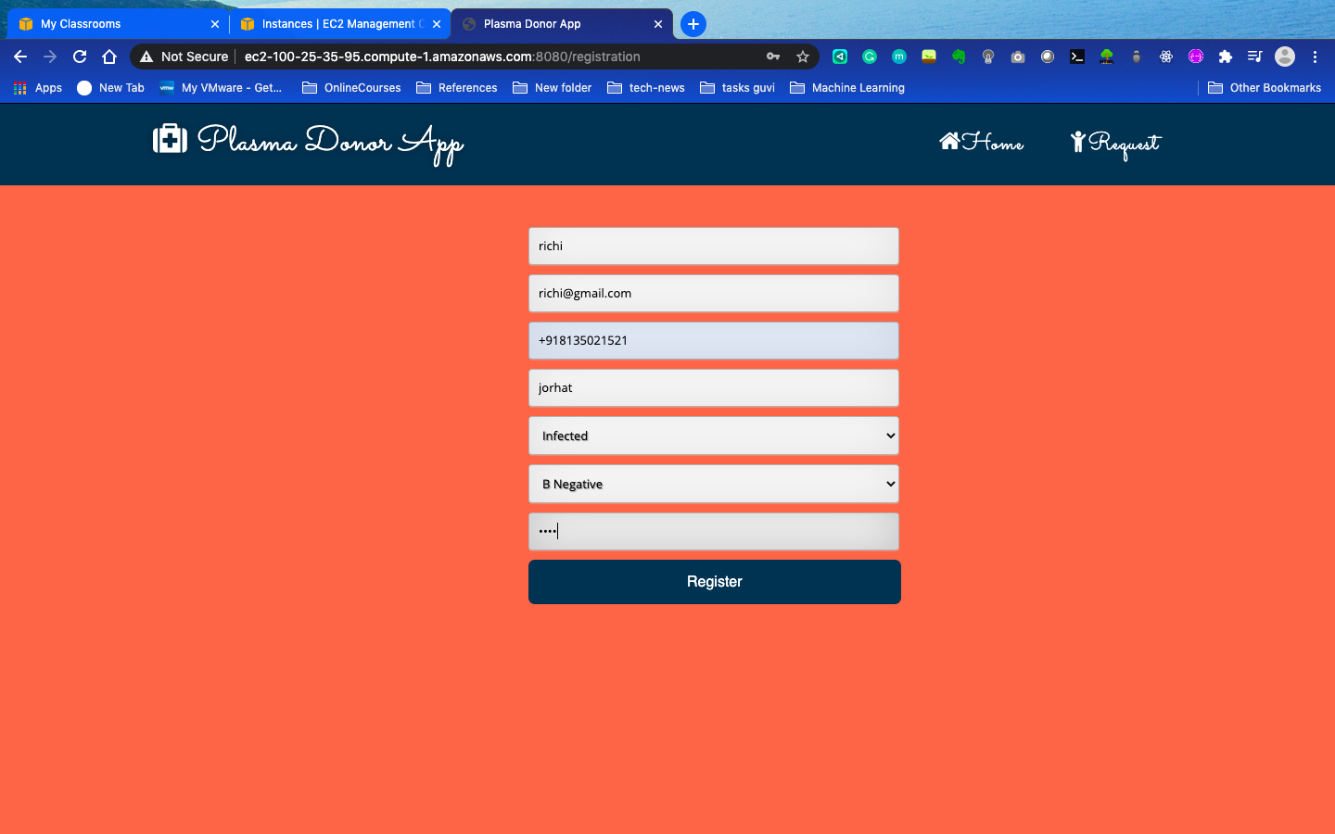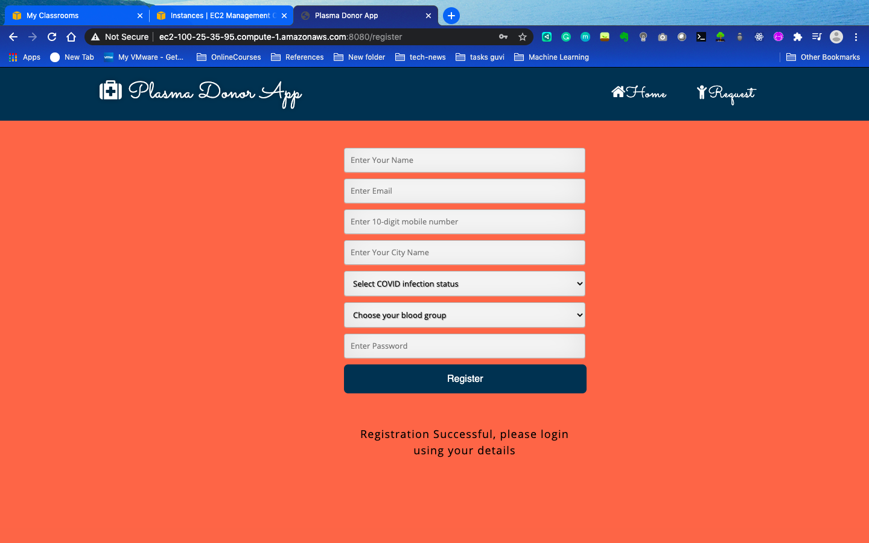

1. **Home Page after Logging in**

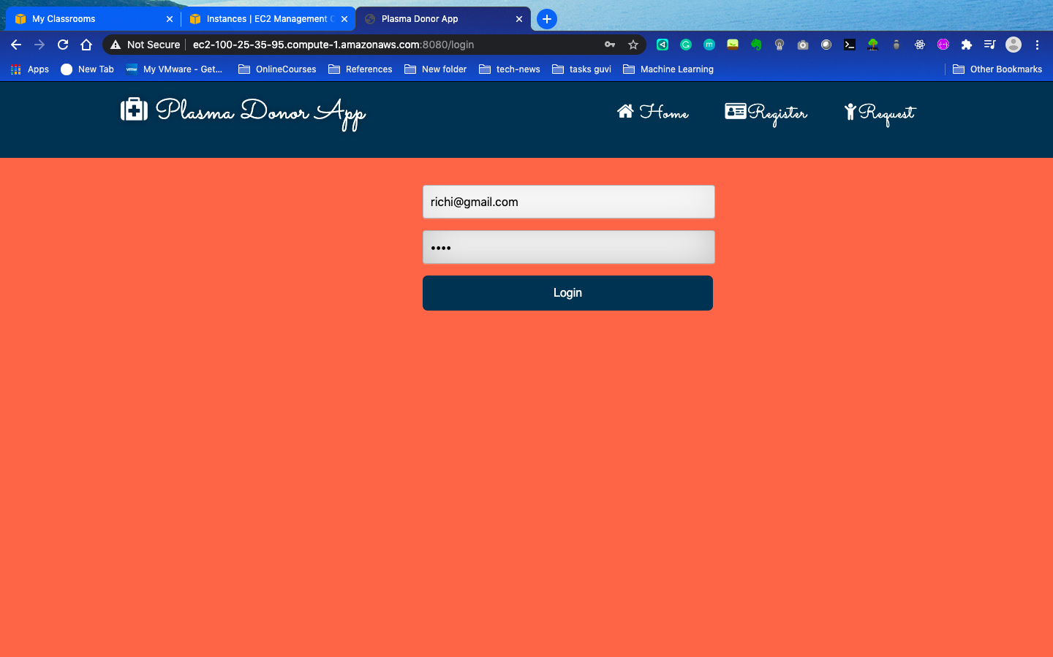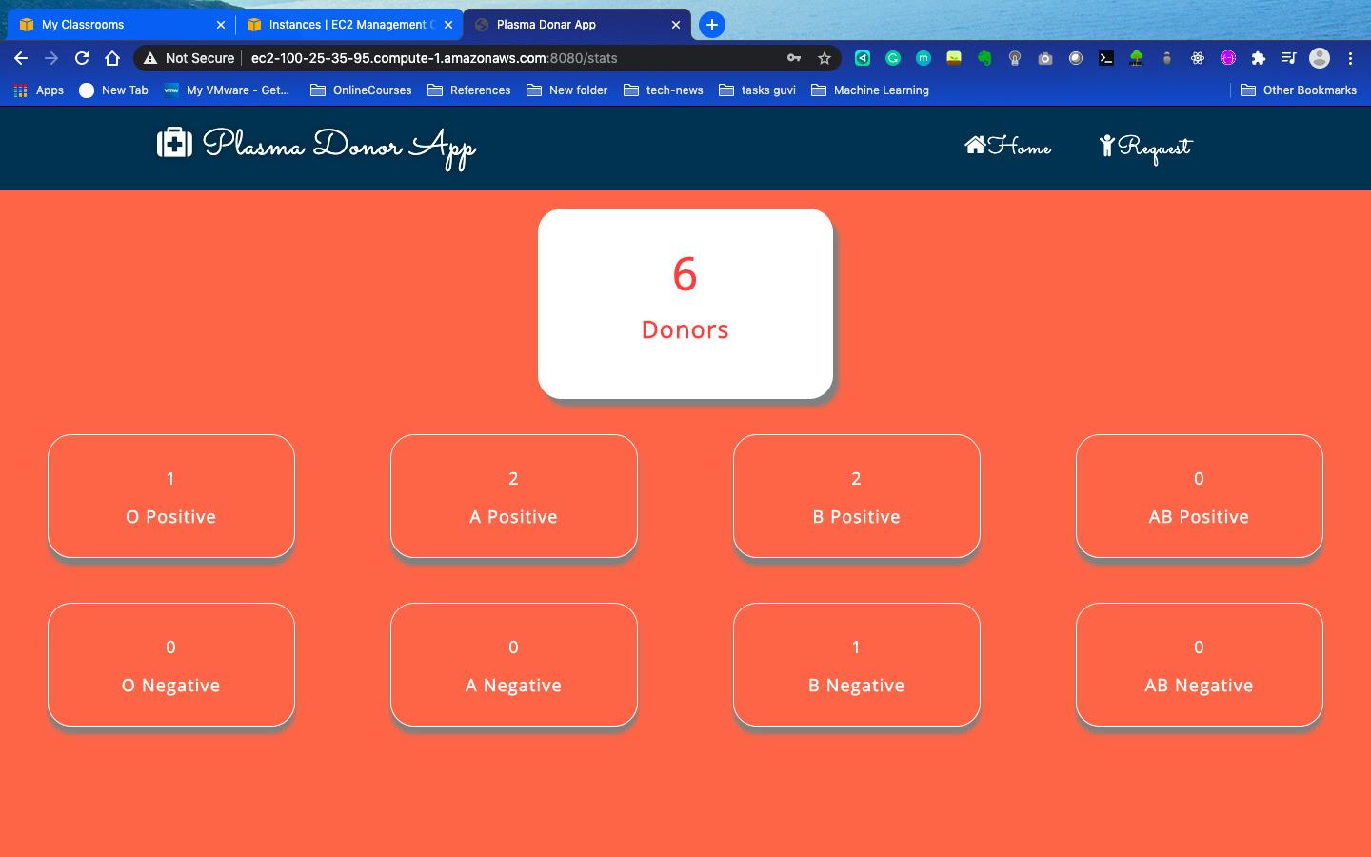

1. **Request Page and the sent Message.**

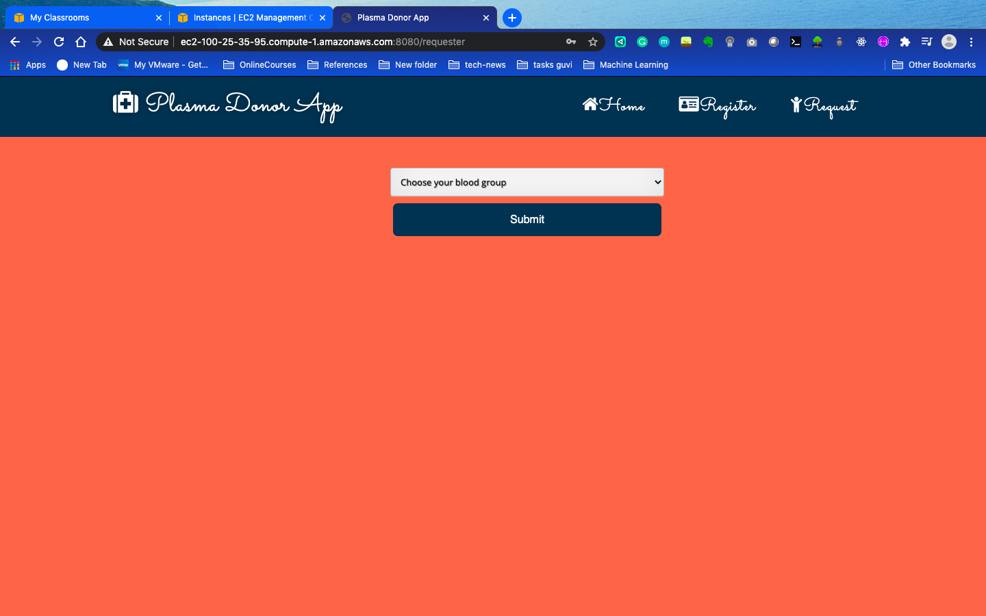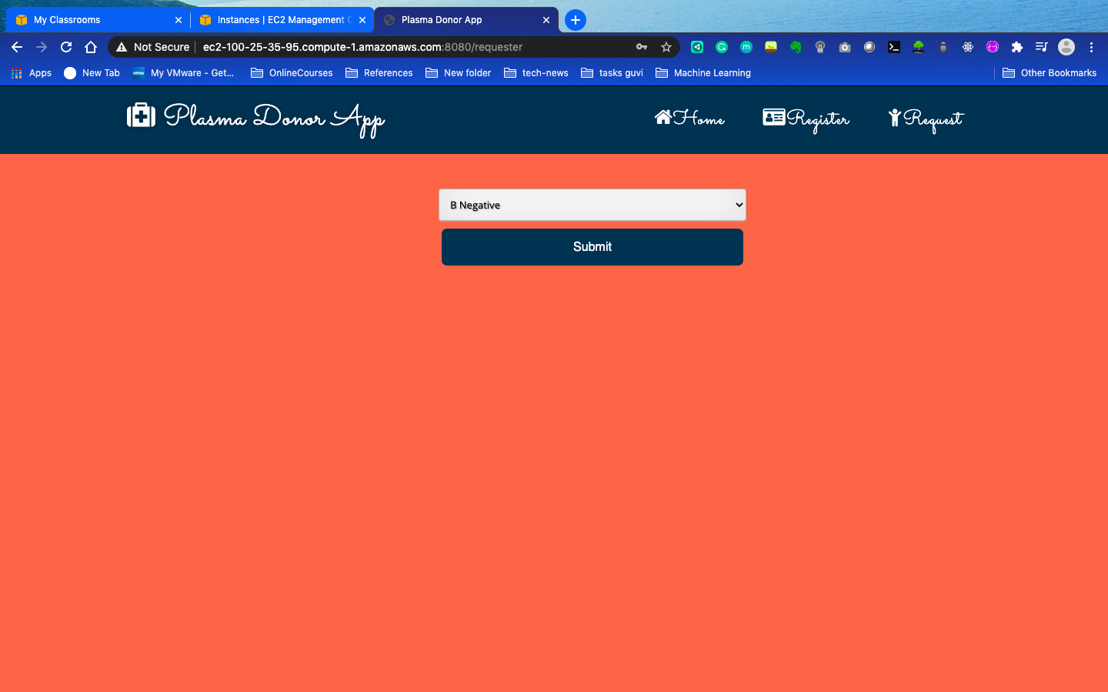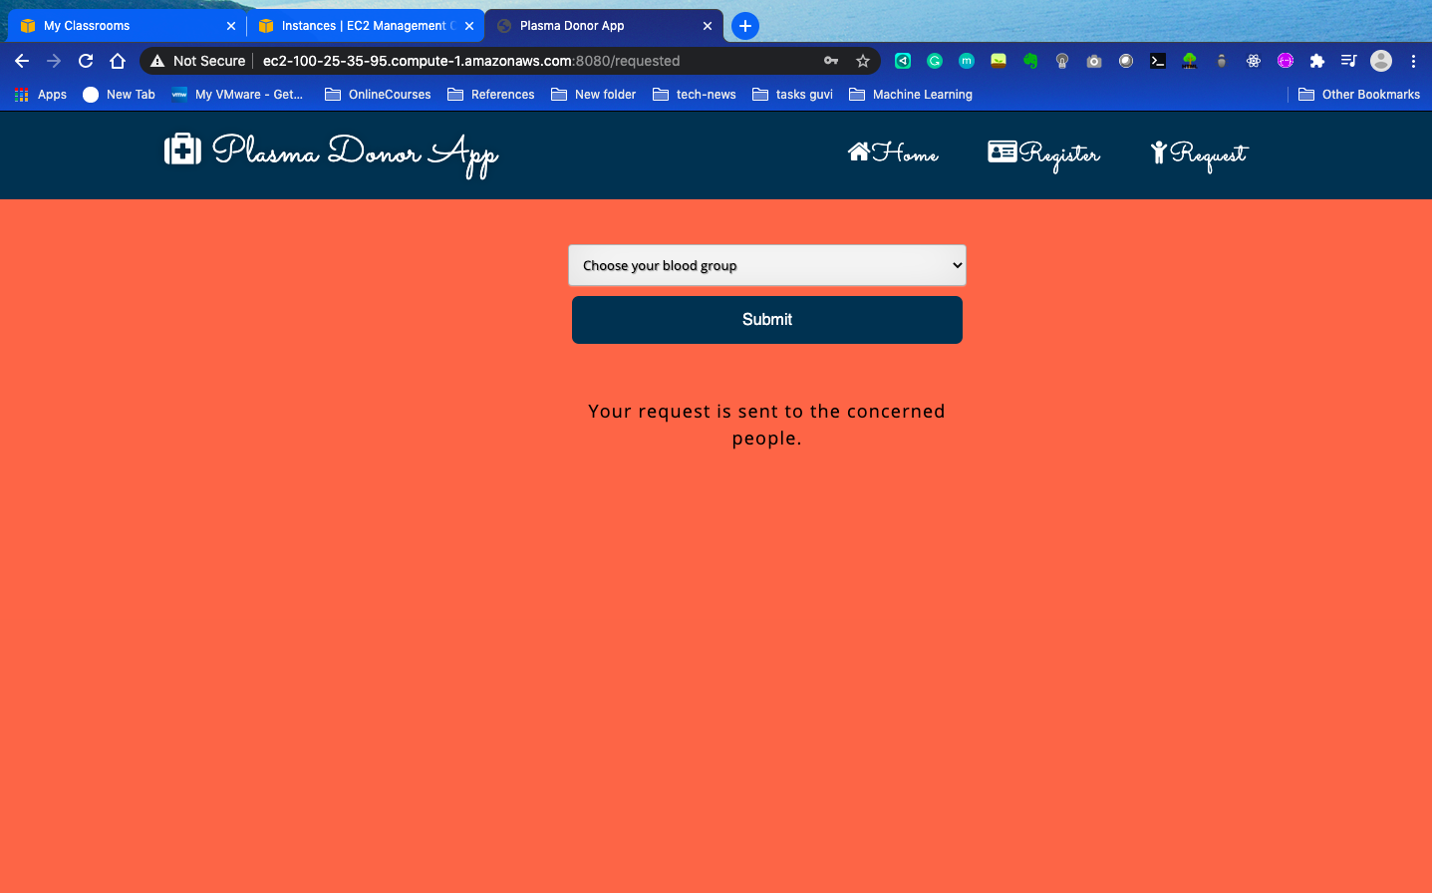



**APPLICATIONS:**

**HEALTH SECTOR:**

* People who want to donate blood can anytime register themselves.The app informs the registered donors whenever their blood is needed. The app is made keeping in mind the distance factor between donor and the patient.

**CONCLUSION:**

In conclusion, Blood Donation App is a very remarkable technology that holds a lot of potential. During the COVID 19 crisis, the requirement of plasma became high and the donor count was low. Saving the donor information and helping the need by notifying the current donors would be a helping hand.

**FUTURE SCOPE:**

Donating does a lot of good. Blood plasma is needed for many modern medical therapies. These include treatments for immune system conditions, bleeding, and respiratory disorders, as well as blood transfusions and wound healing. Plasma donation is necessary to collect enough plasma for medical treatments.

This app will act as a bridge between patients seeking plasma therapy and donors who have recovered.

-----------------------------------*****************-----------------------------------